# **Unit 16 Homework Assignment: Design & Code Your Online Portfolio**

A **designer’s online portfolio** is an extension of their resume. It is a required asset that designers submit when they apply for jobs. Companies’ will evaluate your online portfolio as part of the screening process. Your portfolio is how you showcase your design process, and it’s what will get you your first interview.

Welcome to your fourth design challenge! For this homework, you’ll build your portfolio website. This will give you a chance to practice your UX/UI and FE Dev skills. For the next six weeks, you will be executing the design process as you research, test, define, ideate, prototype, and test a responsive web solution for your case study work. By the end of this project, you will have a responsive website to showcase all your design challenge case studies from the UX/UI Boot Camp. Before you begin the homework, please take a moment to read this document in its entirety.

**Scenario**: This week, we’ll be wearing the hat of a UI/visual designer/FE developer. The deliverable will be to complete an About Me page to highlight your UX/UI/FE Dev skills and practice your HTML/CSS coding.

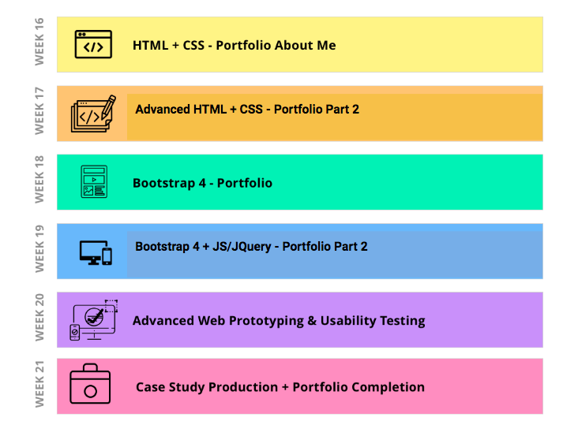

**User Story:** As a UI designer/FE developer, you'll want to understand how people use a About Me webpage design + code a usable interaction.

So, let’s get started! Be sure to read through this document in its entirety. *There are NO shortcuts, coding is hard, and expertise takes time. Don’t give up! Lean on your fellow students, TAs, and Instructor for help, Use Google, and reach out to development communities for help.*

## **Requirements (10–12 hrs to complete)**

Follow these steps to design and code your online portfolio. Note we’ve also given you a time estimate to complete each step.

* **Part 1: Create Web Project Folder Structure (1 hr).**
* **Part 2: Create an HTML + CSS file (1 hr).**
* **Part 3: Create a Wireframe for an About Me Page (1 hr).**
* **Part 4: Code Your Wireframe into a Webpage Using HTML & CSS (5–7 hrs).**
* **Part 5: Upload to GitHub (1 hr).**
* **Part 6: Publish Your Webpage on GitHub Pages (1-2 hrs)**.

## **Instructions**

If you have any coding or GitHub issues, you should first try Googling the errors or checking StackExchange for troubleshooting help. You can also try asking a fellow classmate or TA to help you troubleshoot.

## **Part 1: Create a Web Project Folder Structure**

First, we'll create a GitHub repository for our new project, then we'll clone this project to our local computer. In this folder, you will then create folders and files that will serve as the structure for your Online Portfolio website.

Use VSCode or your OS system to set up your web project folders.

Use VSCode to create the html and css files that you will code in.

1. Go to <https://github.com> to create a new repository.
2. Click the **New** button.

The **Create a new repository** page opens.

1. In the **Repository name** field type **HW-MyFirstLayout** and then click the Create repository button.  
     
   **Note:** You can leave the rest of the default settings selected.

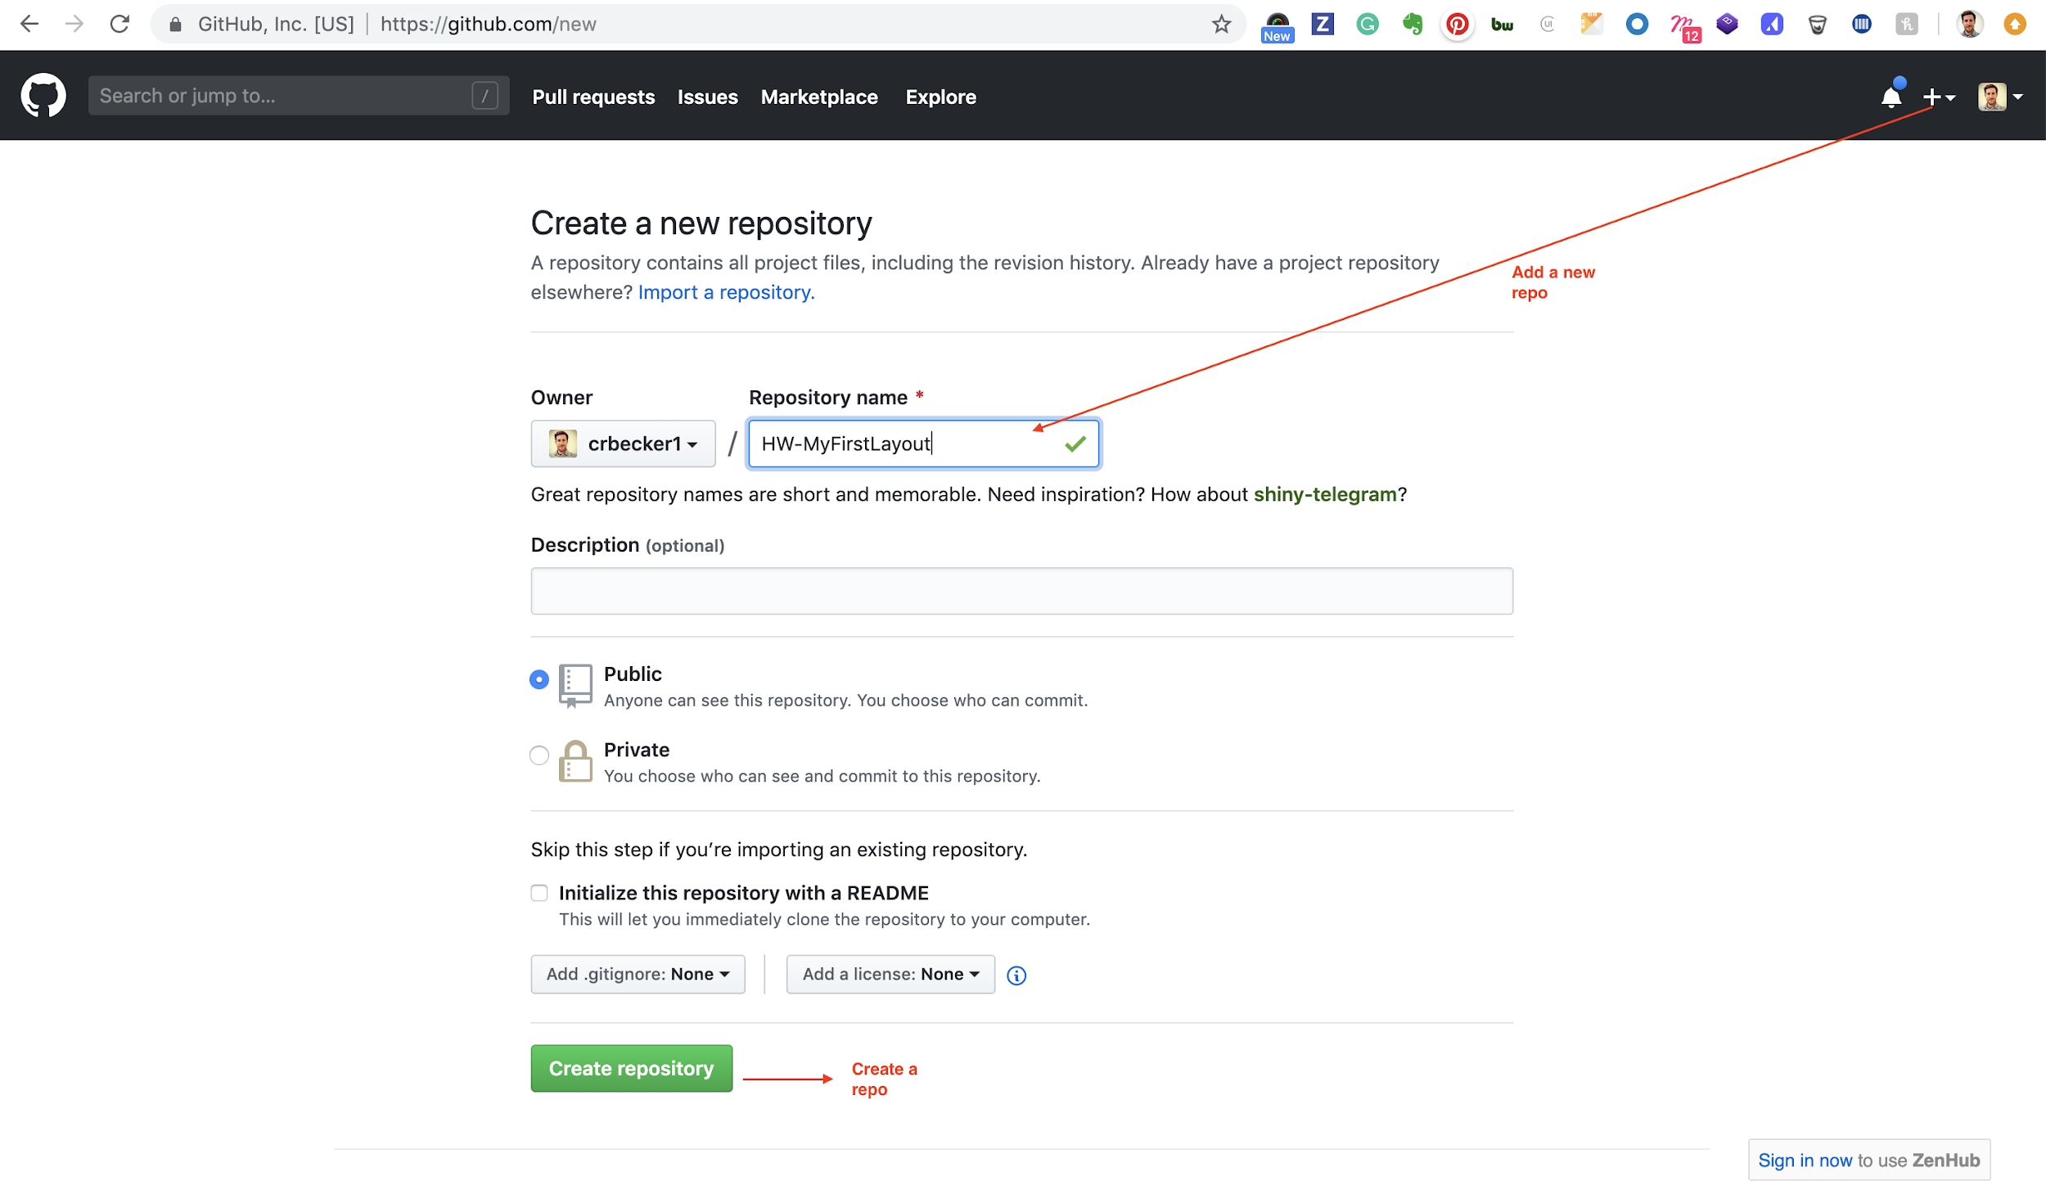

1. Click the **Setup in Desktop** button.  
     
   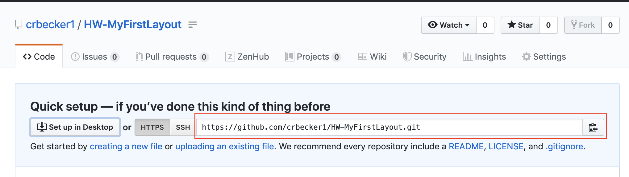

The **Open GitHub Desktop** dialog opens.

1. Click the **Open GitHub Desktop** button.

The **Clone a Repository** dialog opens. The Git repo link should populate, if it doesn't you can paste the link here.

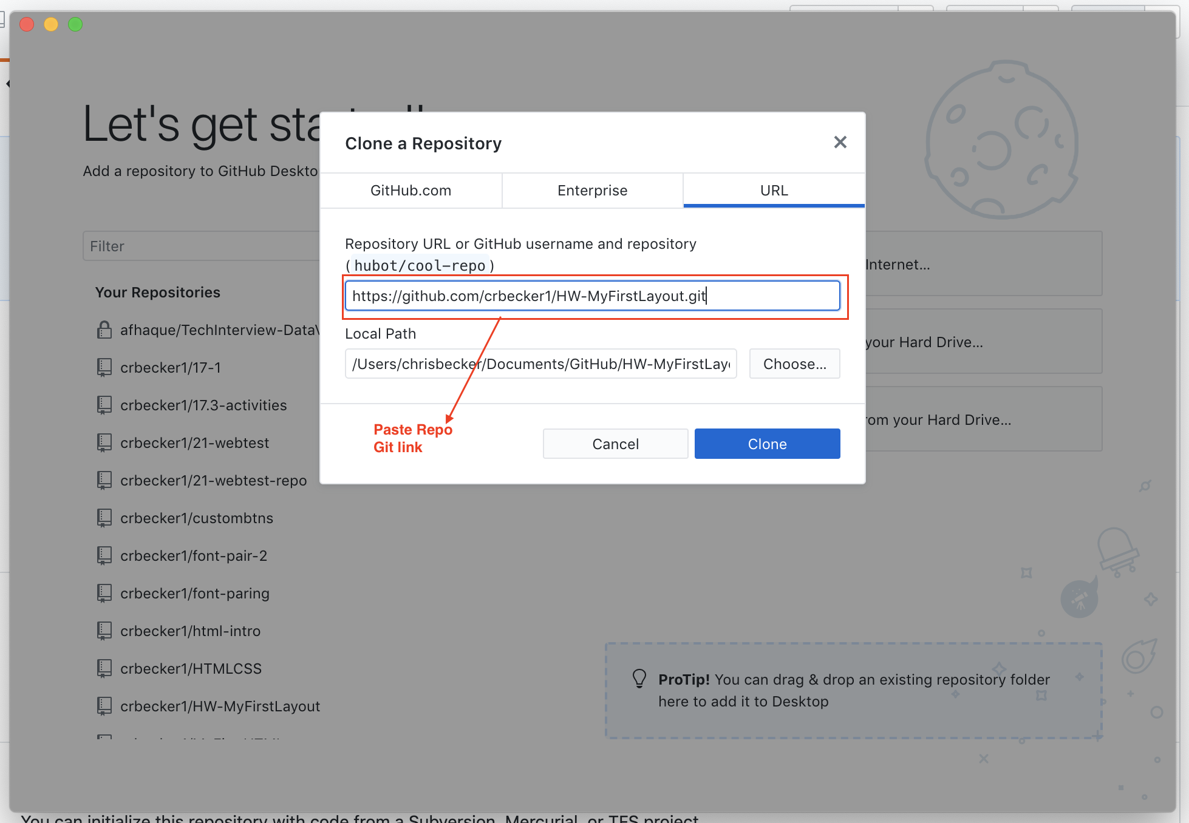

1. Click the **Clone** button.
2. Review your HW-MyFirstLayout repo that you just cloned from the earlier step.

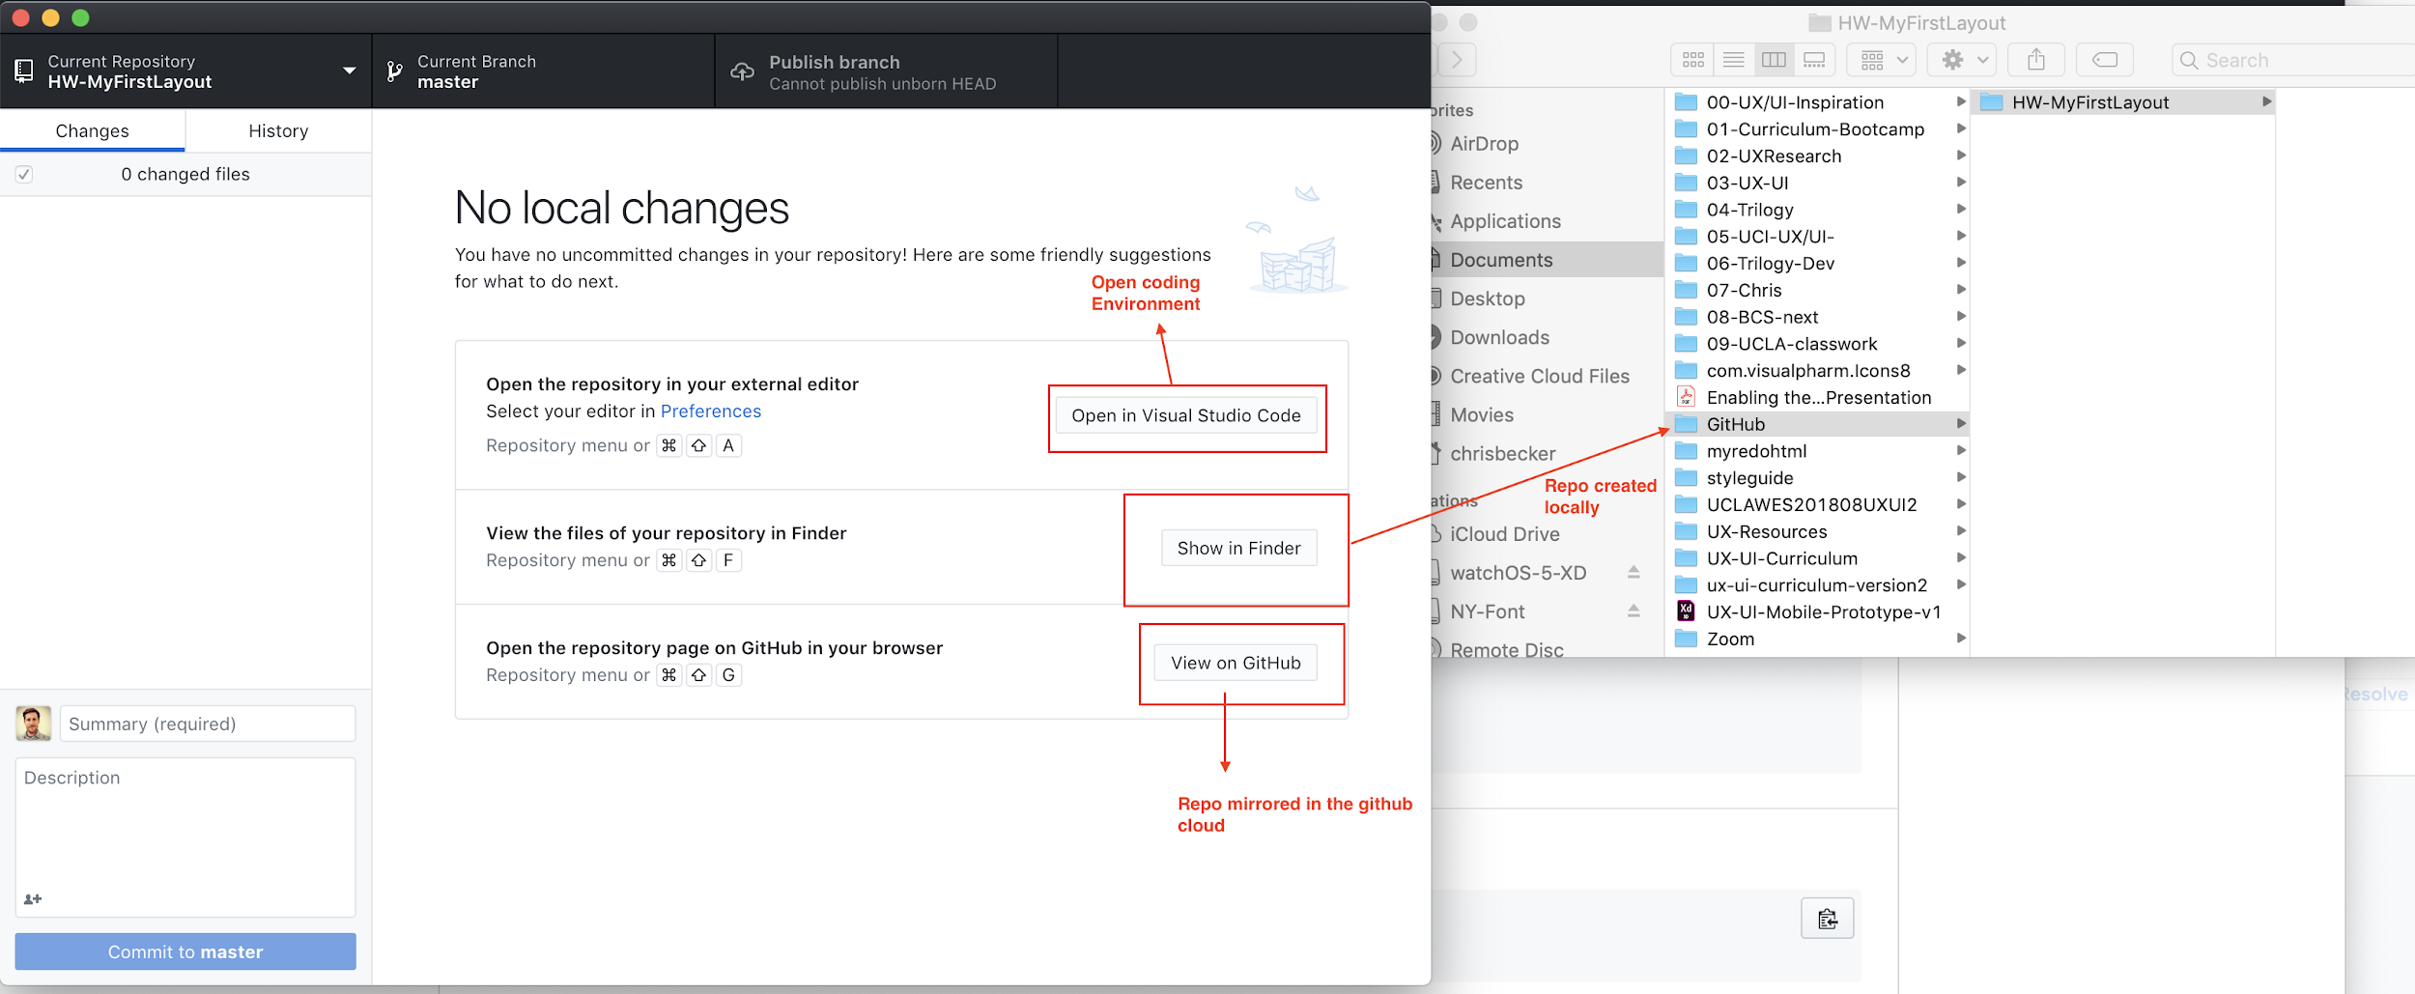

1. Add folders to your repo to reflect the project folder best practices.

* **Create a folder with the project name.** This is the “root” folder of your project otherwise known as the folder that contains all the assets for your website.
* **Create an images folder** to contain any images you use in your HTML.
* **Create a CSS folder** that will contain a file named **style.css**. You will use this file to style your html.

*The following image is an example of the folder structure you are creating:*

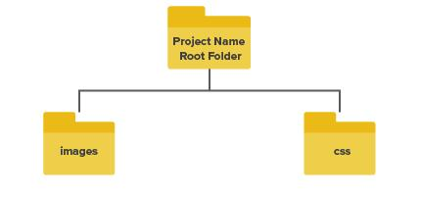

1. Take a screenshot of your root folder and place it in your Google Drive homework folder.

## **Resources**

Feeling stuck? Review these additional resources:

* Watch this [video](https://www.youtube.com/watch?v=RniGO9Ek6yY) to learn how to set up the correct file structure for a website.
* Read the [instructions](https://help.github.com/en/desktop) on how to set up and use GitHub Desktop.
* Read [GitHub Guides](https://guides.github.com/) to understand GitHub workflows, practice the Hello, World exercise, or to get started with GitHub pages.

## **Part 2: Create an HTML + CSS file**

Using VS Code create an HTML file and a CSS file.

1. In VS Code, create an index.html file. This file will hold all the html tags that create the structure of your website
2. Create a style.css file in the css folder. This file will be used to style the HTML tags you created in index.html.

*Scroll down to next page*

The following image is an example of the file & folder structure you are creating:

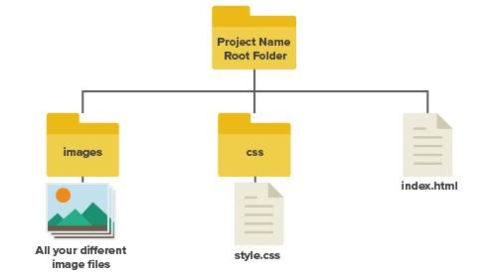

## **Part 3: Design a Wireframe for Your About Me Page**

A website starts with a wireframe, in Adobe XD create your About Me page wireframe.

1. Open XD and create a desktop artboard.
2. Create a wireframe for an About Me page that includes the following content:

* Your Full Name.
* An image of yourself.
* 1–3 sentences describing who you are and how you came to UX/UI.
* 3 links to your social media, for example:LinkedIn, Behance, Dribble, etc..
* A list containing 3 interesting facts and skills about you.

1. Export assets from your design to be used in your web project. Save these image assets in your images folder you created during step 2.
2. Export a .png of your wireframe and add it to the Google Drive homework folder.

## **Resources**

Learn more about sharing prototypes and design specs using [Adobe XD](https://helpx.adobe.com/xd/help/share-embed-designs-prototypes.html).

## **Part 4: Code Your Wireframe into a Webpage Using HTML + CSS**

Using VS Code, code your wireframe into a webpage using HTML + CSS. Your webpage should contain all the elements and content defined in your wireframe from part 3. The goal is to make your coded page look like your wireframe with some added styling.

Don’t be frustrated if your website isn’t a perfect match to your design, remember this is your first website ever so don’t be too hard on yourself.

**Code your HTML file:**

If you need more information on how to use Visual Studio Code (VS Code), you can find information here: <https://code.visualstudio.com/docs/languages/html>.

If you need help using visual studio code watch the following tutorials -> <https://code.visualstudio.com/docs/getstarted/introvideos>

1. In the index.html file, you must use the following tags at least once:
2. A <html></html> tag
3. A <head></head> tag
4. A <link href=”css/index.css” rel=”stylesheet” type=”text/css”> tag that targets a css file in your css folder
5. A <body></body> tag
6. A <div></div> tag
7. A <section></section> tag
8. A <img src=”images/you.png”> tag of yourself
9. A <h1></h1> tag
10. A <p></p> tag
11. A <ol></ol> or <ul></ul> tag containing three <li></li> tags

**To customize your layout, do the following:**

1. In your html file add a CSS style sheet link tag that targets your style.css file located in your CSS folder.

<link rel = "stylesheet" type = "text/css" href = "css/style.css" />

1. In CSS, center image tags of yourself by centering it using the CSS property margin.
2. In CSS, center your text tags by adding the CSS property text-align to the section tag that contains your body elements.
3. In CSS, customize the background color and the color of all elements on your page where appropriate. Use color at your discretion!
4. Customize all the text on your page with the font-family property.

## **Bonus**

If you're feeling adventurous, add a pattern or image to your section tag using the property background-image. Make sure to read the documentation first: <https://www.w3schools.com/cssref/pr_background-image.asp>.

1. Add more sections to this template.
2. Add a section about your favorite hobby.
3. Add a section that showcases the work you have done in the past.

## **Part 5: Upload to GitHub via GitHub Desktop**

Now that you have started to code your About Me webpage, let’s practice pushing changes locally to your GitHub repo.

1. In GitHub Desktop, add a commit to save your changes locally.

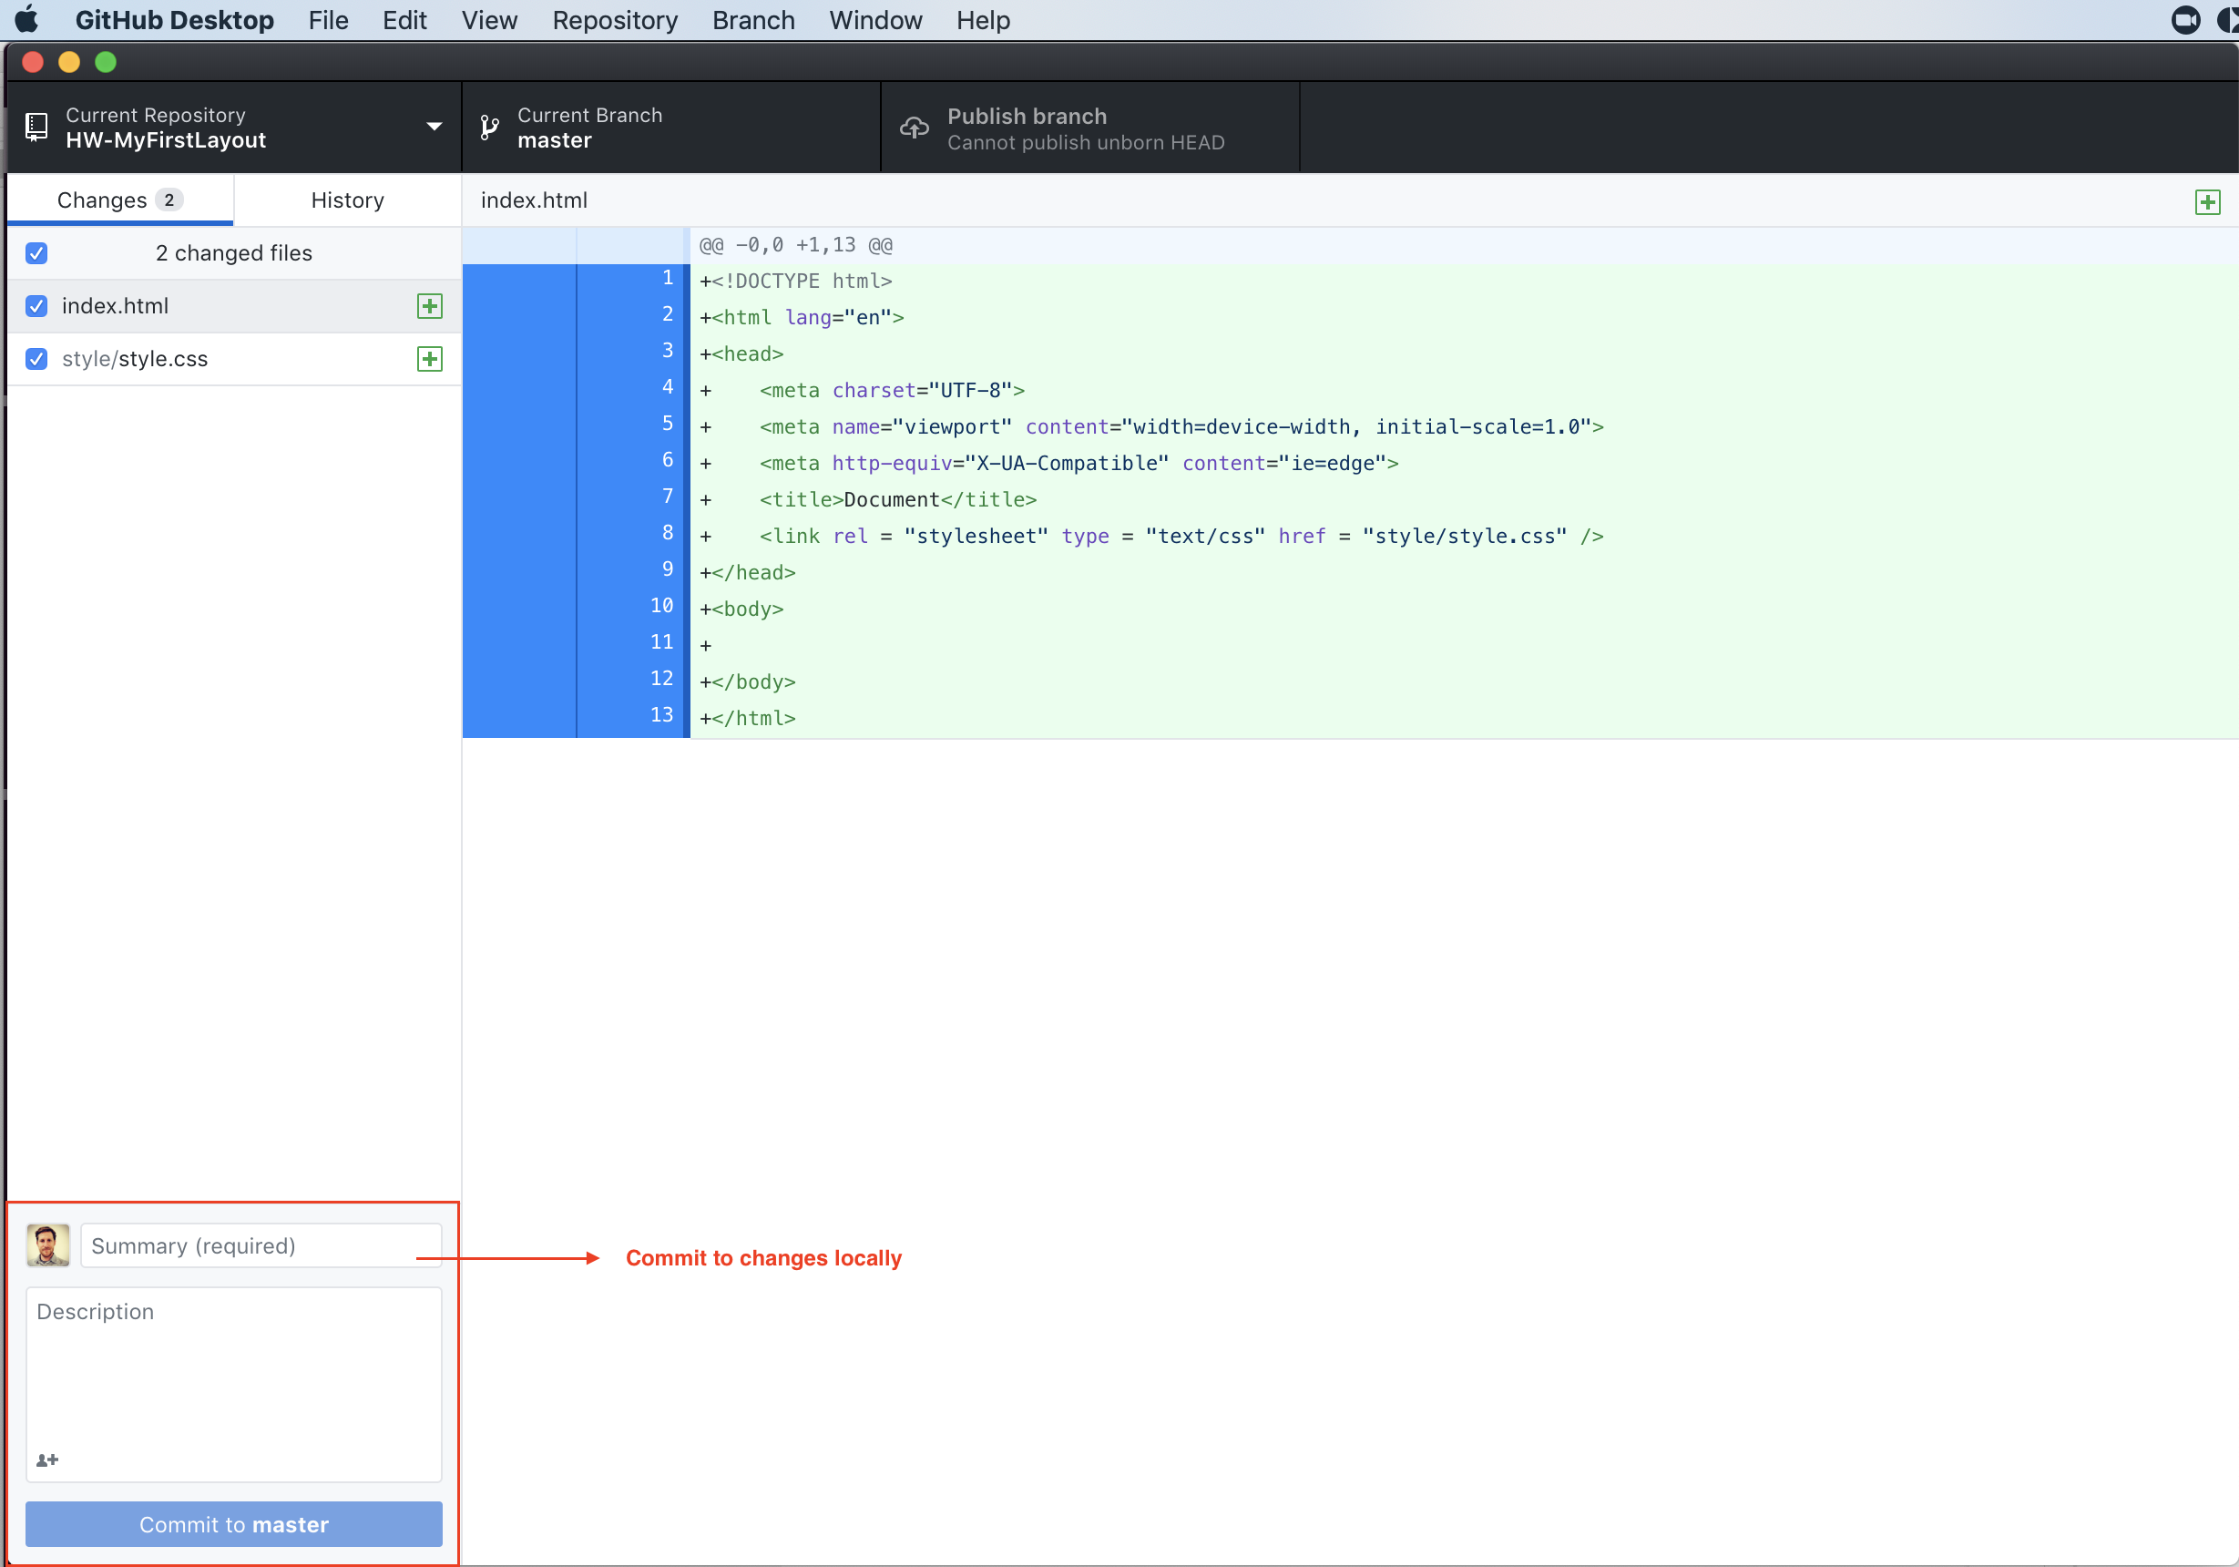

1. Add a commit message.

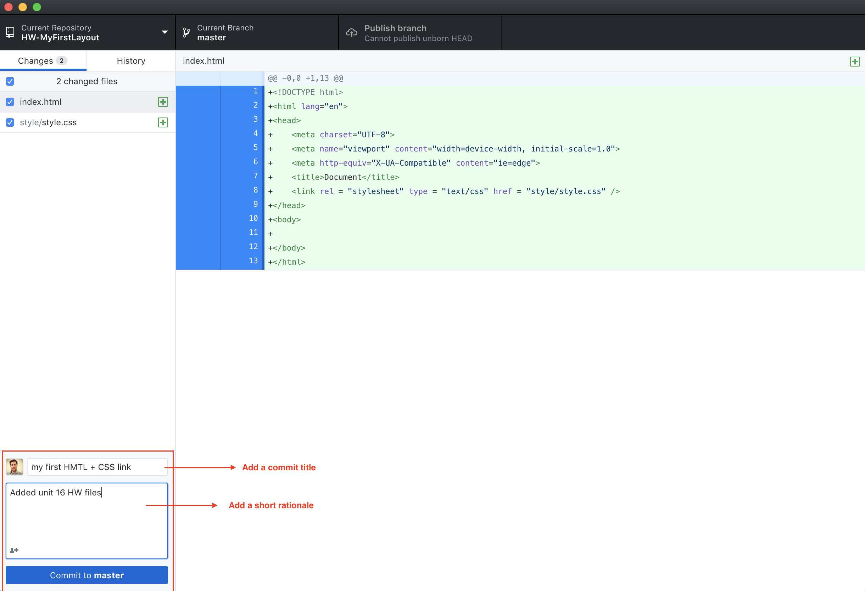

1. Click the Commit to master button to push your commit (local changes) to GitHub from GitHub Desktop.

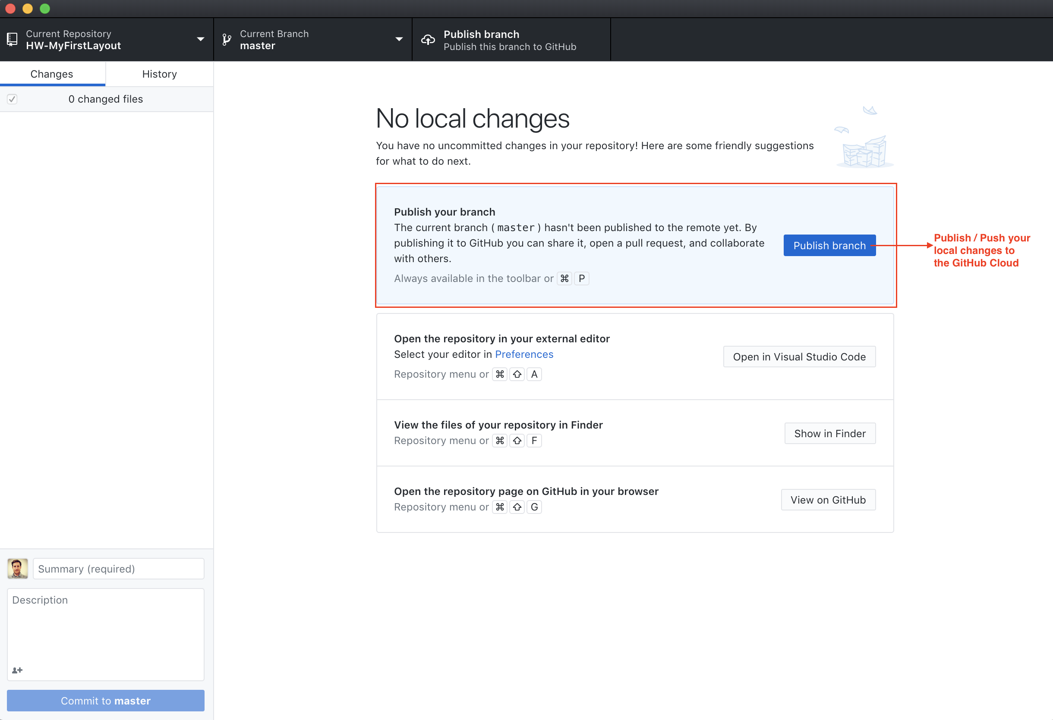

1. Check that your HTML and CSS files have been uploaded to your HW-MyFirstLayout GitHub repo.

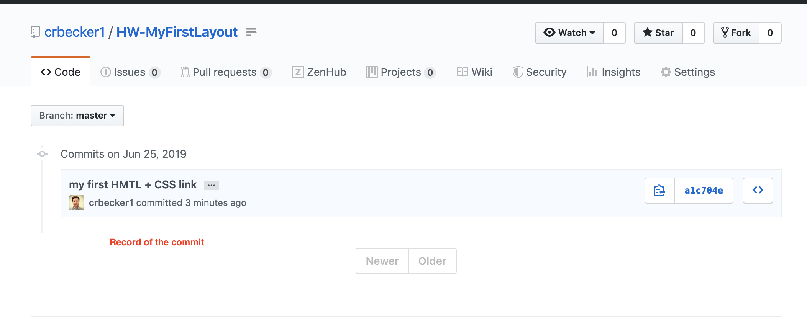

1. Copy the GitHub repo link and add the link to your Google Doc in your Google Drive.

## **Part 6: Publish your Webpage to GitHub Pages**

Once you have finished coding your HTML and CSS files for your About Me page, it is time to practice publishing to the web through GitHub.

1. Publish the HW-MyFirstLayout page on GitHub pages. In the GitHub repo, select Settings:

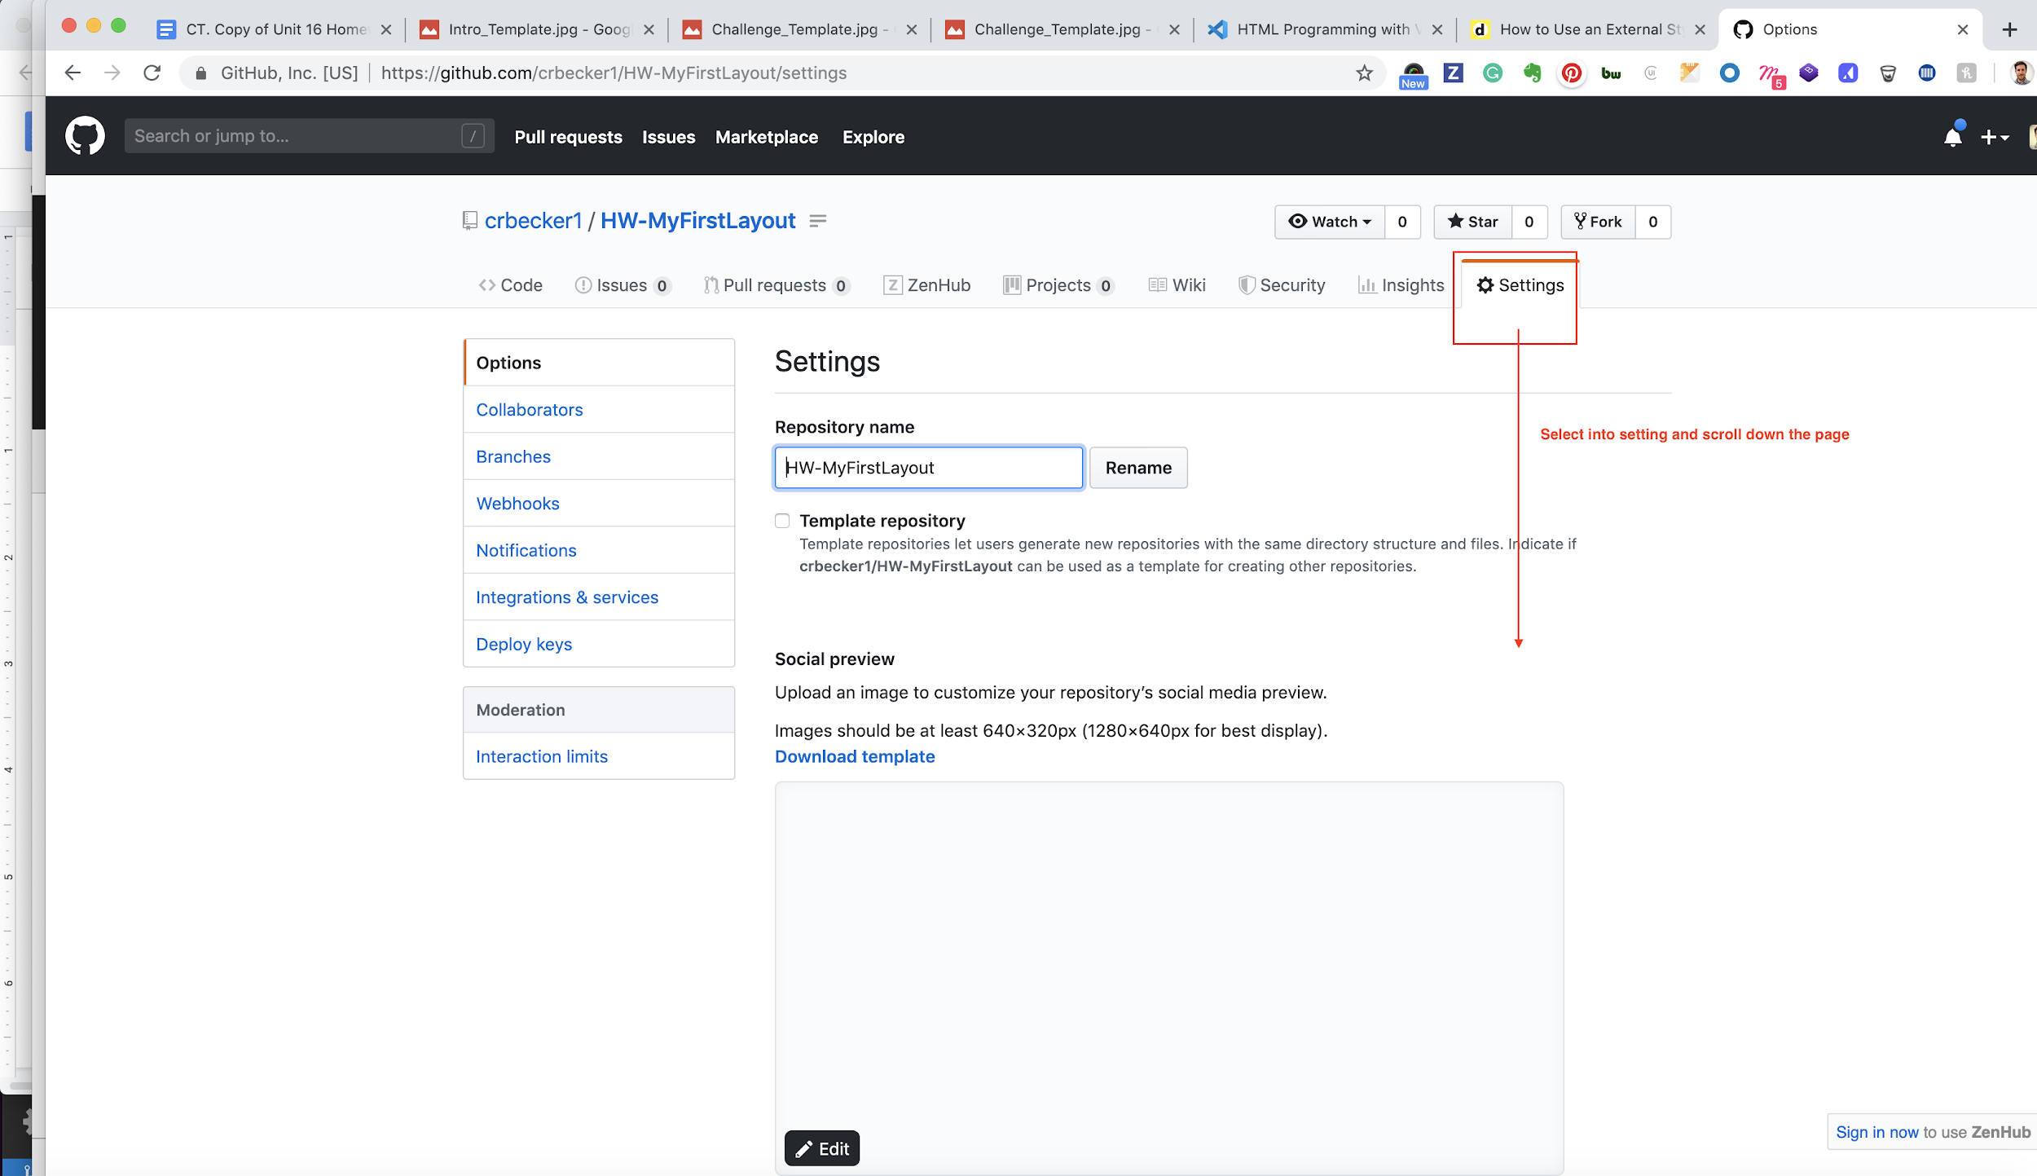

1. Scroll down to the GitHub Pages section and select master branch from the dropdown list.

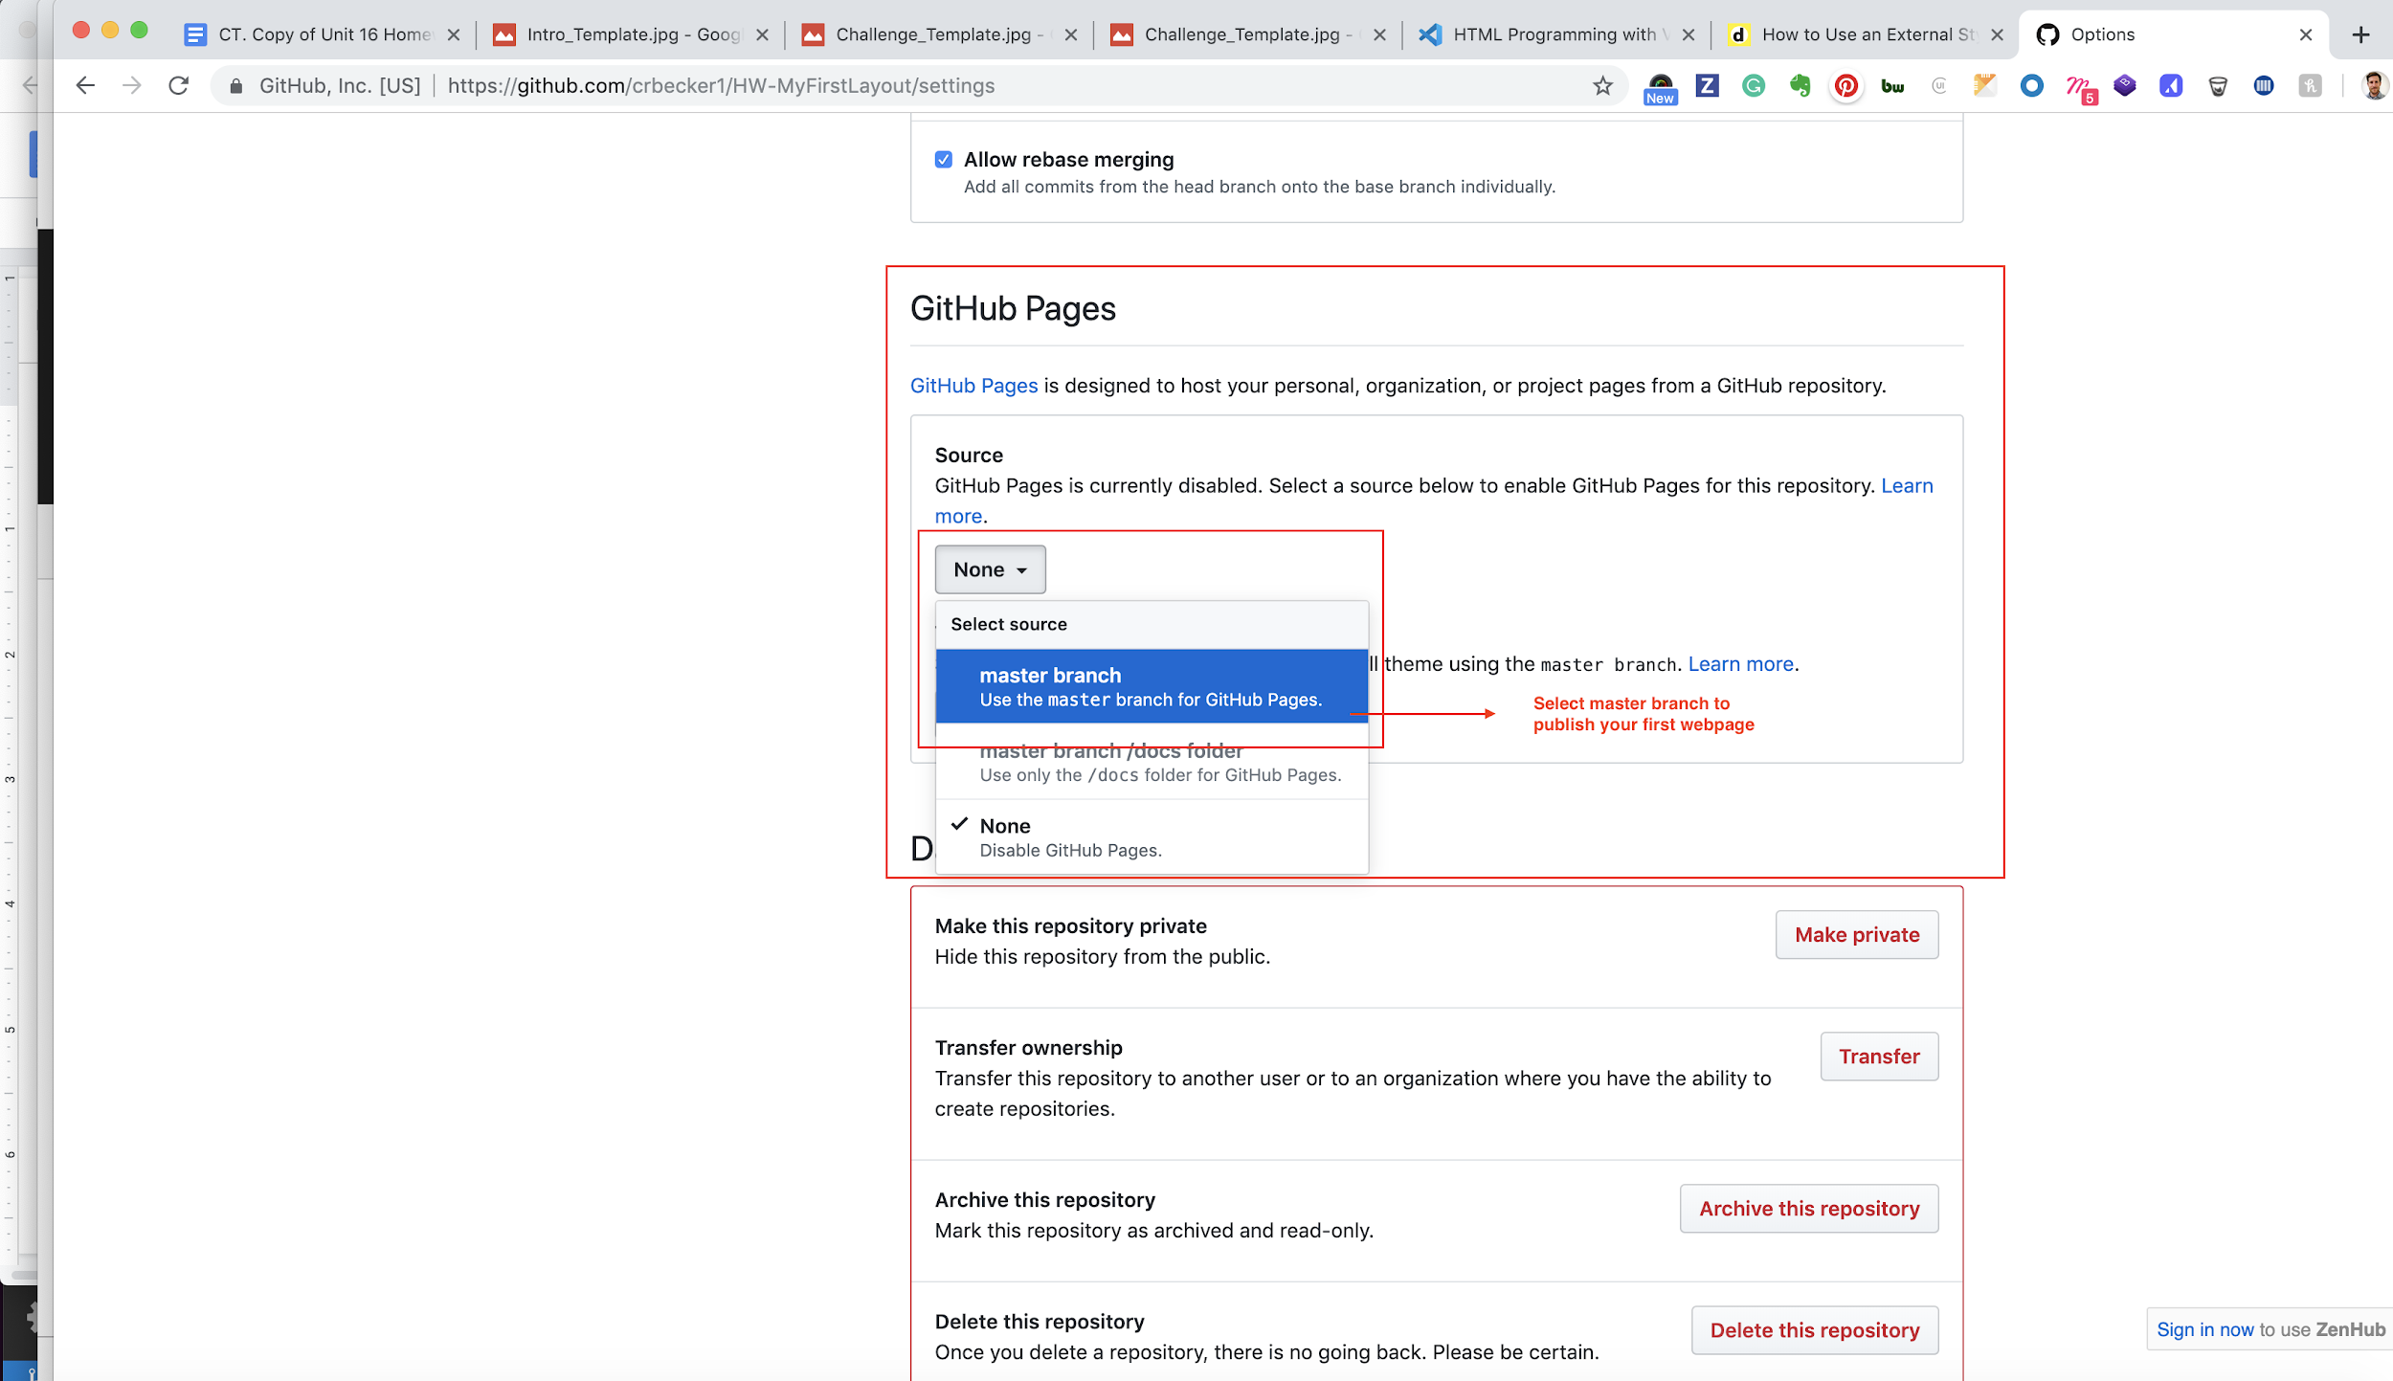

**Note:** Remember, you must have a file named index.html for GitHub pages to display your page correctly! By default, GitHub page’s server looks for index.html as the first file it will load.

1. Copy your webpage URL and paste into your Google Doc in your Google Drive.

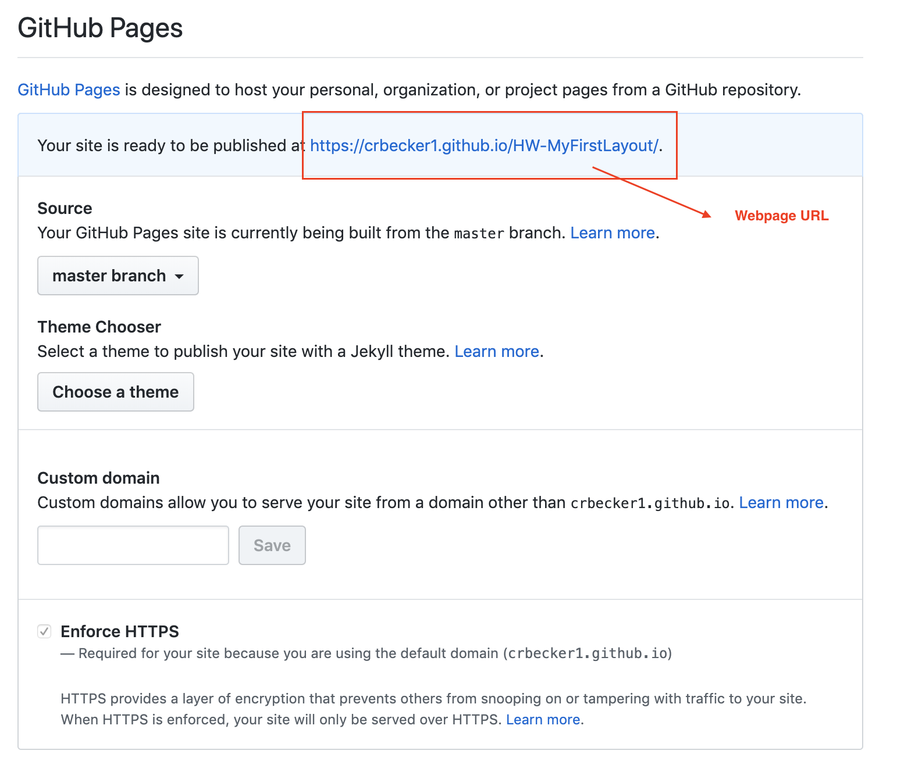

## **Resources**

Learn more about [GitHub Pages](https://pages.github.com/) and how to [get started](https://guides.github.com/features/pages/) using them.

## **Examples of Polished Online Portfolios**

Need inspiration? We’ve curated some student projects from other classes for you to review. Keep in mind that these projects have had several rounds of iteration. Review the [previous student portfolios here](https://drive.google.com/open?id=13teMaDhVz2uQHdv5Qo7PapIt0KSVEcG_).

## **How to Submit Your Homework**

For this homework, you will turn in your assignment using Google Drive and Google Docs.

Each student must submit the following deliverables:

1. A link to your Google Drive folder. **Your Drive folder should contain the following deliverables:**

* A screenshot of your folder structure.
* An image of your About Me wireframe.
* A Google doc that contains two links to:

1. Your GitHub repository that contains your files.
2. Your project hosted on GitHub pages.